Frederick Gent School
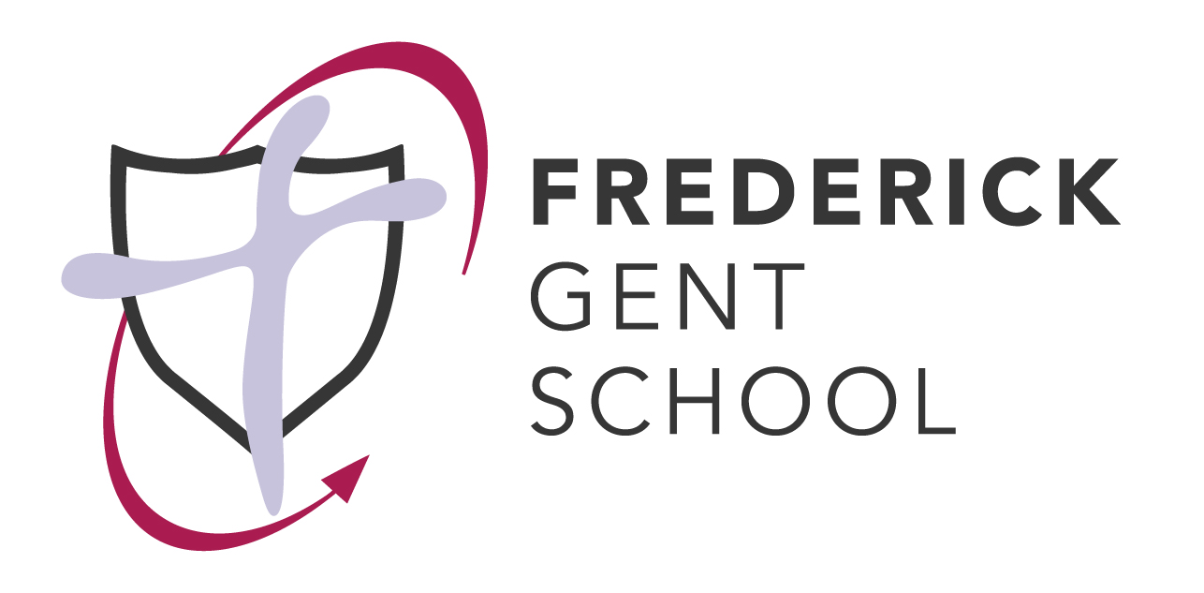
Remote learning user documents and agreements

October 2021

Frederick Gent School
Remote Learning: Parental Agreement
Having read the “Remote Learning: Responsible User Agreement for Students” with your child, please read this document carefully. Please complete and submit the Parental Consent Form on google forms.
In the case of school closure or students being asked to self isolate due to COVID-19 the school has access to remote learning resources to support students. These include:
- the use of Show my homework for task setting, sharing resources and for teachers to give marks and feedback,
- the delivery of online lessons, including live lessons, by a teacher to classes or groups using Teams.
- the use of Kerboodle, Pearson Active Teach, Seneca Learning, google classrooms to provide learning resources.
Parental consent is needed to enable students to take part in any online home learning sessions where there is live interaction with a teacher or other students.
To facilitate remote learning using online interactive sessions, parents are asked to:
- encourage, support and monitor your child's work.
- find them an appropriate place to work with minimal distractions.
- ensure your child is appropriately dressed, in accordance with expectations on a non-uniform day.
- ensure that communication in online sessions is between student and teacher or student to student if a teacher sets up any group work.
- ensure pupils know not to record any sessions or share any comment about lessons, teachers or remote learning on public forums
- ensure pupils know not to share any links to live lessons with any other person
Parents should not take part in online lessons although you may choose to sit in the background if this makes you feel more comfortable. If you have any concerns about the lesson and how it has been conducted, please contact the school and your concerns will be addressed by an appropriate member of staff.

Remote Learning
Responsible User Agreement for Students
I take responsibility for my use of technology when I use remote learning. This means:
- I am responsible for all my actions and behaviour online
- I will discuss how I will be using technology for online learning with my parents and let them know when I will be online for this
- I will not reveal my password(s) to anyone
- I will not share links to online meetings, meeting codes or other electronic resources provided by the school with anyone.
- I will use technology and school resources as directed by my teachers
- I will not deliberately browse, download, upload or forward any material that could be considered offensive or illegal. If I accidentally come across any such material I will report it to my teacher and a parent
- As far as possible, I will be online punctually for home learning sessions. I will take part and complete work to the best of my ability
- I will take part in remote learning sessions in a suitable environment and will be dressed appropriately
- I will give feedback to my teachers on my experiences, make any relevant suggestions and report technical problems to my teacher
- I will follow the existing rules for behaviour in class, so I will make sure that all communications with teachers and fellow students are sensible and considerate and I will use appropriate language. This also means that I will not be using any phone or other smart device for other purposes during sessions, such as using social media or listening to music.
- I will not record, take photos or video my fellow students or teachers during online sessions
- I will sign out from online sessions promptly at the end or when requested to do so by my teacher.
- I will only log into lesson links which I am expecting and which have been posted in SMHW.
- Should I receive Team invites/calendar links unexpectedly I will not click on these and will report this to the school immediately
- I will not share any transcripts or recordings of lessons made by my teachers with anyone, except parents.
- I understand that when using online learning resources my use can be monitored and logged by the school and can be made available to my teachers.

I understand that these rules are designed to keep me safe and help me learn as well as I can. I also understand and accept that if they are not followed, the school may inform my parents and apply serious sanctions and I will be removed from the live lesson or a series of live lessons.

Frederick Gent School
Safeguarding guidelines and considerations whilst using Teams for remote learning
Safeguarding remains the key priority of all staff. These guidelines are designed to safeguard the students and yourself. It is essential that you follow these guidelines.
- Only students in your teaching class should be invited into the session. The session link will be available from the calendar on Teams. DO NOT share this link via text, social media or in any other format
- Only use the platform (Teams) which has been approved by school for face to face online lessons and only access this using your school email account to log in
- Prior to starting the lesson you should consider the environment from where you will be hosting the meeting:
  - You should have a neutral background behind you e.g. a blank wall. Your background should not include any personal information
  - Try and ensure that there are no other conversations, loud noises etc which could distract from the lesson. Be aware that people walking in may share details or make comments which are inappropriate in the classroom environment
  - If your home environment is not conducive to hosting the meeting it may be better to deliver the lesson from an empty classroom.
- You should be fully dressed in a manner which would be appropriate in the classroom on a non-uniform day. You should not be in pyjamas or in a state of semi undress.
- You should have read and be familiar with the school’s policies on safeguarding (including the new appendix to the policy covering safeguarding during school closure due to COVID-19)
- If a parent, student or member of staff raises a concern about the lesson the school will follow the managing allegations against staff policy, including where appropriate, referral to the LADO.
- Students should attend your remote learning session dressed as appropriate for a non-uniform day and should be sat in an appropriate location. If there are any issues the student should be removed from the lesson and the student reported immediately to the leadership team
- If you have any worries about the students, their presentation, emotional health, safety and wellbeing following a remote learning session, either due to something the student has said, comments you have heard in the background or something you may have seen, you must report this on My Concern following normal procedures
- Do not be in a meeting room alone with a student. When setting up your session ensure that the waiting room is turned on. Only turn on your video and audio once there are two or more students in the waiting room and your co-host has been admitted.
- Disable private messaging so students can’t have a conversation which you are not part of
- The only screen which should be shared is the teachers. You can set this control within Teams.
- Lessons should be recorded for the purpose of safeguarding and stored on the Z drive or one drive. Recordings should not be shared on show my homework.

